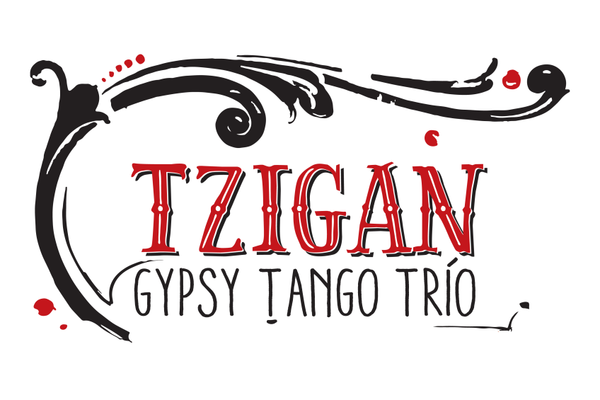

PRESS QUOTES

"Unique... A singular rythm with argentine flavor; fresh air for gypsy music..."

- Rumbos Magazine

"The band especially create an impact with their fantastic sightless interaction. Each break, each unisono, each time change functions as if from one single cast.
The other of the band´s strenghts is the loud-picturesque representation of musical images. It´s the travelling people who carry the manifold musical influences from
all around the world within themselves."

​

​
- Ingolstadt Donaukurier

"Music made of almost violent constrasts between the rise of anger and the despondency of the melancholy. (...) a very good work, original and played with the necessary intensity. The trio is one of the most attractive groups that offers our scene."

​
- La Voz del Interior

"... the melodic and lyric depth takes us on a ride between wagons and routes of Russian gypsies. With instrumental virtuosity and a deep respect for lyrics..." "...tremendous melodic rises of the violin are accompanied or sometimes event doubled by the accordion, so enarmonic and, as the guitar, very forceful."

​
- La Docta Jazz

